Project Report - Speaker with AUX Input (LM386 Audio Amplifier)
Table of Contents
Introduction: 1
Final circuit: 2
System Description: 2
Calculations and Design Decisions: 2
AUX Input and Stereo-to-Mono Mixing: 2
Choosing the Potentiometer Value 3
Input Coupling and C6 Capacitor: 3
LM386 Audio Amplifier 3
Output coupling capacitor 3
High-Frequency Stability 4
Results 4
Conclusion 4
References 4

Introduction:
This project focuses on designing and building a simple audio speaker system that receives a standard 3.5mm AUX input.
The system accepts a stereo audio signal (Left/Right), mixes it into a mono channel, amplifies it using an LM386 audio amplifier, and drives an 8Ω speaker. The project demonstrates fundamental audio-electronics concepts including AC coupling, filtering, signal mixing, and amplification.

Final circuit:
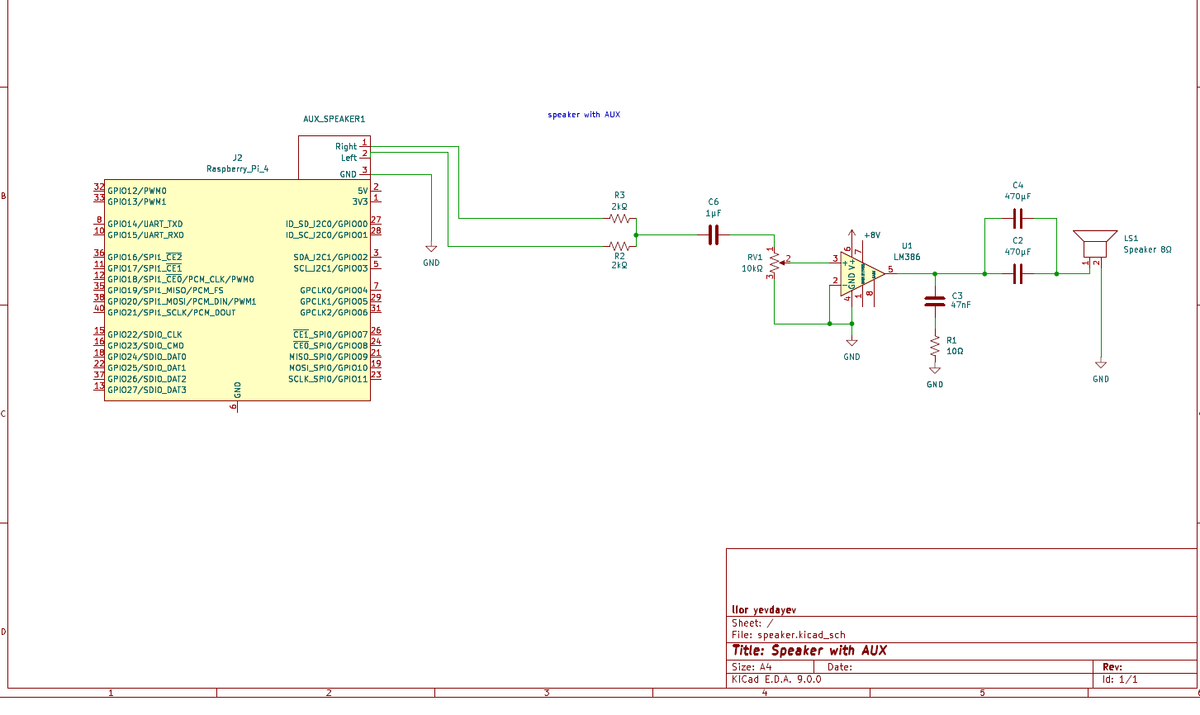

System Description:
The system consists of the following major components:
- AUX 3.5mm stereo input
- Stereo-to-mono mixing stage using two 2kΩ resistors
- Volume control using a 10kΩ potentiometer
- LM386 audio amplifier
- Capacitors for filtering, stabilization, and gain control
- Zobel Circuit
- 8Ω speaker
- 8V DC power supply
The circuit was implemented on a breadboard and designed using KiCad.

Calculations and Design Decisions:

AUX Input and Stereo-to-Mono Mixing:
The AUX connector receives two AC audio signals:
- Left channel
- Right channel
- Ground
Because the system uses a single mono speaker, the Left and Right channels must be mixed.
This is done using two 2kΩ resistors (R2 and R3).
These resistors safely combine the channels into one mono signal without shorting the Left and Right outputs of the audio source. The resistors also ensure proper impedance and prevent distortion or damage to the source device.

Choosing the Potentiometer Value
The voltage drop depends on the parallel combination of the potentiometer and the amplifier input. Therefore, the potentiometer should be roughly of the same order of magnitude as the amplifier input to allow good control of the voltage.
- If the potentiometer is too low: the voltage becomes very small, making the speaker mostly quiet.
- If the potentiometer is too high: it is difficult to reduce the volume, and the voltage drop is not significant, making it hard to control the volume.
Thus, a 10kΩ potentiometer is a suitable choice.

Input Coupling and C6 Capacitor:
Between the mono mix and the potentiometer sits the capacitor C6 (1µF).
Its role is to serve as an AC coupling capacitor, blocking DC components and allowing only the audio AC signal to pass.
This provides three main benefits:
- Prevents DC offset from reaching the potentiometer or the LM386 input.
- Forms a high-pass filter with the input impedance, shaping the low-frequency response of the system.
The chosen cutoff frequency was the minimum frequency humans can hear, so =20 Hz. This requires a capacitor of approximately 1µF
C6$=\frac{1}{2π⋅(50K||10K)⋅20}=0.95µF≈1µF$

LM386 Audio Amplifier
The LM386 is a low-voltage audio amplifier designed for small speaker applications.
Key characteristics include:
- Operating voltage of 4–12V
- High input sensitivity suitable for line-level signals
- The LM386 allows a minimum gain of 20

Output coupling capacitor
I used a large output capacitor to protect the speaker from DC while allowing strong bass frequencies to pass.
The chosen cutoff frequency was the minimum frequency humans can hear,$f_{c}=20HZ$ This requires a capacitor of approximately 940µF, calculated as:
C$=\frac{1}{2π⋅8⋅20}=994µF$
Since I didn't have a capacitor of this exact value, I used two 470 µF capacitors in parallel, which gives a total capacitance of 940 µF. This results in a cutoff frequency of approximately 21.16 Hz, which is very close to the chosen cutoff frequency 20 Hz.

High-Frequency Stability
A Zobel circuit is used at the amplifier output to improve high-frequency stability. It compensates for the rising impedance of the speaker at high frequencies, preventing:
- Oscillations in the amplifier
- Distortion at high frequencies
- Unstable operation of the audio system
The Zobel network consists of a series resistor and capacitor connected in parallel with the speaker, which stabilizes the load seen by the amplifier and ensures smooth frequency response. I added a 10Ω + 47nF Zobel network to stabilize the amplifier at high frequencies and prevent oscillation.

Results
The system successfully amplifies external AUX audio sources such as smartphones, laptops, or media players.
The audio output is clean, stable, and sufficiently loud for small-scale use.
Noise levels are low due to proper AC coupling, filtering, and bypass capacitors.

Conclusion
The project demonstrates a practical and efficient implementation of a mono AUX speaker system using the LM386 amplifier.
It showcases essential analog electronics skills such as signal mixing, filtering, AC/DC separation, and audio amplification.
Potential future improvements include creating a PCB, adding a tone control module, or integrating Bluetooth input.

References
  - Texas Instruments, “LM386 Low Voltage Audio Power Amplifier Datasheet (Rev. D),” SNAS545D – May 2004, Revised August 2023. Available: https://www.ti.com/lit/ds/symlink/lm386.pdf
  - Murphy, John L., “Neutralizing L(e) with a Zobel”, TA Speaker Topics, TrueAudio.com, Updated 27 January 2024. Available: https://www.trueaudio.com/st_zobel.htm

